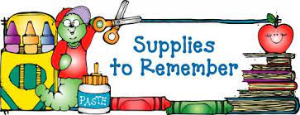

Second Grade

* 2 Poly (Plastic) pocket folders (No prongs)
* 4 Composition notebooks (No spiral notebooks)
* 3 Packs of wide-ruled filler paper
* 2 Packs of 24 pencils
* Pencil sharpener with cover
* 2 Boxes of 24 count Crayons
* 4 Glue Sticks (No liquid glue)
* Packs of Dry Erase Markers
* Pair of USB headphones (No earbuds please)
* Book Bag (No rolling book bags please)

**Wish List**

* 1 Box of Mr. Clean Magic Erasers
* Ziploc bags (quart or gallon)
* 1 pack of sheet protectors
* Pack of Dry Erase Markers
* Pack of Highlighters
* Index Cards
* Construction Paper
* Box of Tissue

**Supplies to have a home**

* Crayons
* Scissors
* Glue Sticks
* Wide Ruled notebook paper
* Pencils/Sharpener